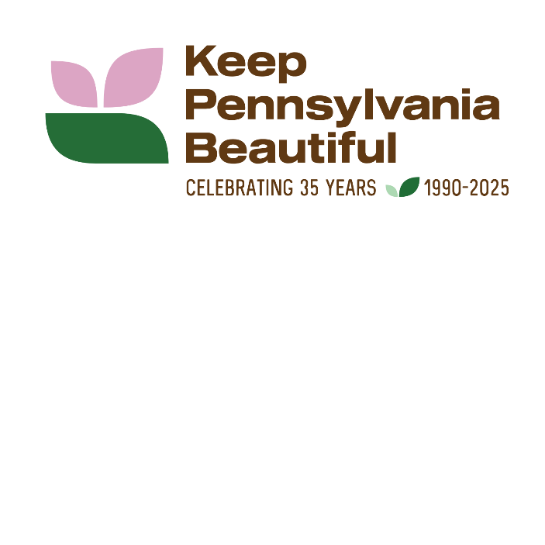

KEEP PENNSYLVANIA BEAUTIFUL - PICK UP PENNSYLVANIA
The state’s largest community improvement initiative
Sample Social Media Posts

FACEBOOK AND INSTAGRAM
Promote your local event:
- We're excited to announce our participation in Keep Pennsylvania Beautiful's PICK UP PA, Pennsylvania’s largest community improvement initiative! Let's come together to make a difference in our community.
Date: [Insert Date]
Location: [Insert Area Name]
Every piece of trash we collect will contribute to our state and national cleanup efforts. Let's show our pride and make our neighborhood shine! See you there!
2. (Name or Organization) is hosting a Keep Pennsylvania Beautiful PICK UP PENNSYLVANIA event by planting trees and flower bulbs at (local park/area of event). You are invited to help us keep our neighborhood clean and beautiful! To participate, contact (insert event date and directions on how to register with your group).
- We are gearing up for our annual cleanup of (name of area/road/park). Keep Pennsylvania Beautiful is providing cleanup supplies through their PICK UP PENNSYLVANIA initiative, the state’s largest community improvement initiative. There will be a friendly competition to see who can find the most unusual item. Join us on (date) by contacting (contact information).
- Meet neighbors and help keep your community clean and beautiful. We are planning a cleanup of (area/road/park) on (date). Keep Pennsylvania Beautiful is providing cleanup supplies through their PICK UP PENNSYLVANIA, the state’s largest community improvement initiative. Register here (registration info or link to contact).
- We need a cleanup crew to help pick up trash along (area/road/park) on (date). Keep Pennsylvania Beautiful is providing cleanup supplies through PICK UP PENNSYLVNIA, the state’s largest community improvement initiative. Many hands make light work. Contact (contact info).
Promote Keep Pennsylvania Beautiful’s PICK UP PENNSYLVANIA initiative
- Help celebrate Keep Pennsylvania Beautiful’s 35-year anniversary by registering an event with Pick Up Pennsylvania, the state’s largest community improvement initiative. Registered events can get free trash bags, gloves, and safety vests sponsored by the PA Department of Environmental Protection and PennDOT from March through May, as supplies last. For more information visit, https://www.keeppabeautiful.org/programs/pick-up-pa/.

- This year Keep Pennsylvania Beautiful is celebrating 35-years of community improvement. Join the celebration and register a cleanup, tree planting, recycling initiative or anti-litter education event with PICK UP PENNSYLVANIA and receive free bags, safety vests and gloves, as supplies last. Visit www.keeppabeautiful.org.

- According to the Pennsylvania Litter Research Study sponsored by the Department of Environmental Protection, PennDOT and Keep Pennsylvania Beautiful, the presence of litter in an area will likely attract more litter. Join PICK UP PENNSYLVANIA, the state’s largest community improvement initiative, from March 1 through May 31 and receive free trash bags, safety vests and gloves, as supplies last. Visit www.keeppabeautiful.org.

- As part of PICK UP PENNSYLVANIA, the state’s largest community improvement initiative, the Pennsylvania Department of Environmental Protection and Pennsylvania Waste Industries Association are sponsoring trash disposal, free or at a reduced cost, for registered programs at participating landfills from April 1 through April 30, with prior approval. Register your event here: www.keeppabeautiful.org.

- Over 3.3 million pounds of trash and recyclables were picked up by 77,367 volunteers from March through May last year during Keep Pennsylvania Beautiful’s PICK UP PENNSYLVANIA, the state’s largest community improvement initiative. If everyone picked up one bag of litter this spring, the results would be powerful. Visit www.keeppabeautiful.org.

SUGGESTED HASHTAGS:
#PUPA
#PickUpPennsylvania
#PickUpPA
#PAFightsDirty
#EveryLitterBitMatters
Tag our page on Facebook, Instagram, and or LinkedIn posts: Facebook and LinkedIn: @ Keep Pennsylvania Beautiful Instagram: @keeppabeautiful

